Carbody Structure and Exterior

Introduction

Use

Purpose

Parts List

All figures are assigned to an individual page unless views are required to show a complete listing of equipment.
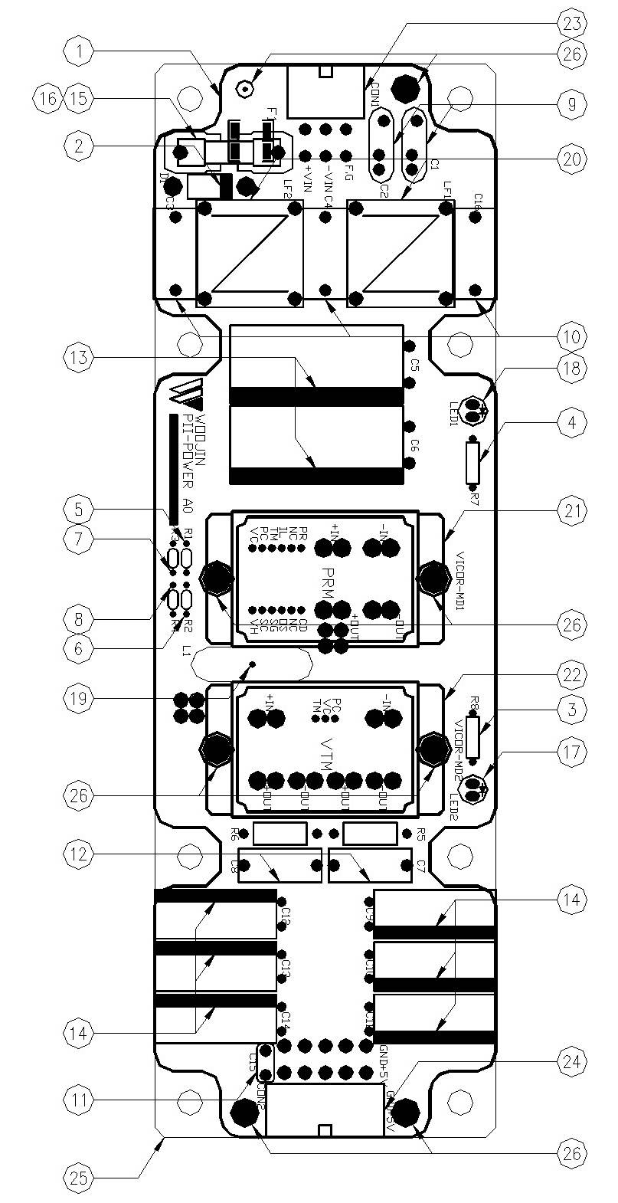

Figure 2.1. PII Power Board
Table 1 - Figure 2.1. pII Power board
FIG No. | PART NUMBERS |  |  | ITEM DESCRIPTION | VENDOR CODE | QTY
 | HRC | VENDOR | DTP
1 |  | PII-POWER A0 |  | . BOARD | HANSAEM | 1
2 |  | UF5408 |  | . FAST RECOVERY DIODE | RECTRON  VISHAY | 1
3 |  | MRS1/4W2.2KΩFTB  MGR251/4W2.2KΩFTP  SN1/4KT52R2.2KΩF |  | . CARBON FILM RESISTOR | ABCO  RARA  JEIL | 1
4 |  | MRS1/4W6.8KΩFTB  MGR251/4W6.8KΩFTP  SN1/4KT52R6.8KΩF |  | . CARBON FILM RESISTOR | ABCO  RARA  JEIL | 1
5 |  | MR1/8W820ΩFTB  MFR0318FAEW8200MA  SN1/8KT52R820ΩF |  | . CARBON FILM RESISTOR | ABCO  RARA  JEIL | 1
6 |  | MR1/8W2KΩFTB  MFR0318FAEW2001MA  SN1/8KT52R2KΩF |  | . CARBON FILM RESISTOR | ABCO  RARA  JEIL | 1
7 |  | MR1/8W8.2ΩFTB  MFR0318FAEW8R20MA  SN1/8KT52R8.2ΩF |  | . CARBON FILM RESISTOR | ABCO  RARA  JEIL | 1
8 |  | MR1/8W15ΩFTB  MFR0318FAEW0150MA  SN1/8KT52R15ΩF |  | . CARBON FILM RESISTOR | ABCO  RARA  JEIL | 1
9 |  | SDE2E472  HCFZ2G472MAAP10 |  | . CERAMIC CAPACITOR | SAMWHA  NETRONTECH | 2
10 |  | PCX2-337-10224  MPX224K31D5 |  | . FILM CAPACITOR | PILKOR  CARLI | 3
11 |  | PCMT-365-85104  EB1J104K |  | . FILM CAPACITOR | PILKOR  SAMHWA | 1
12 |  | MPE630V333K |  | . FILM CAPACITORS | SUNGHO | 2
13 |  | KXL(NXB)63VB1000M7.5TP  RD1J108M16025PA |  | . ELECTROLYTIC CAPACITOR | SAMYOUNG  SAMWHA | 2
14 |  | KXL(LXZ)10VB1500M5.0TP  RD1A158M10016PA |  | . ELECTROLYTIC CAPACITOR | SAMYOUNG  SAMWHA | 6
15 |  | 0215010.MXP  55T 250V 10A |  | . FUSE | LITTLE FUSE  ORISEL | 1
16 |  | FH51  GF205 |  | . FUSE HOLDER | YEONHO  GEO YOUNG | 1
17 |  | 5GG4SD-01, HIGH  SM5311, Y-GREEN |  | . LED | DAGUANG  AUK | 1
18 |  | 5R3SDA, HIGH  SR5311, RED |  | . LED | DAGUANG  AUK | 1
19 |  | 4uH/10A, Φ20, CH203125 |  | . POWER INDUCTOR | TAESUNG  DAEKWANG | 1
20 |  | 2mH/3A, Φ12, RA |  | . LINE FILTER | TAESUNG  DAEKWANG | 2
21 |  | PR036A480T012FP |  | . DC/DC CONVERTER | VICOR | 1
22 |  | VT048A060T040FP |  | . DC/DC CONVERTER | VICOR | 1
23 |  | LAD1140-06P |  | . CONNECTOR | HANLIM | 1
24 |  | LAD1140-10P |  | . CONNECTOR | HANLIM | 1
25 |  | AI, D220 X L70 X H12 |  | . HEAT SINK | EGPOWER | 1
26 |  | ROUND, M3XL6mm |  | . BOLT |  | 8

